Chapter 9
Building and Deploying Web Applications
About This Chapter
In this chapter, you’ll learn how to publish your completed Web applications on a Web server for general use. You’ll also learn how to monitor and maintain the application when it’s in use so that it continues to perform well as the demands of your users change.
Before You Begin
To complete this chapter, you must:
- Have access to a Web server either through a Web hosting service or through your local area network.
- Have successfully completed one or more of the Web applications in this book.
- Be familiar with Microsoft Internet Information Services (IIS) and the Microsoft Management Console (MMC).
- Have installed Microsoft Visual Studio .NET Professional, Microsoft Visual Studio .NET Enterprise Developer, or Microsoft Visual Studio .NET Enterprise Architect. This requirement applies only to the last lesson in this chapter.
Lesson 1: Building a Web Application
At its simplest level, building an application in Visual Studio .NET requires almost no effort. In fact, the application is built automatically any time you click Run while developing or debugging the application.
However, when you are ready to deploy your application, you need to take these additional steps before building it:
- Set the build options.
- Identify the application.
- Configure the application.
In this lesson, you’ll learn how to perform these tasks to prepare your Web application before deployment.
After this lesson, you will be able to
- Build a release version of a Web application
- Add name, company, copyright, description, and version information to the application’s assembly
- Set the application’s configuration options in its Web.config file
Estimated lesson time: 10 minutes
Setting Build Options
Web applications have two build options: debug and release.
To change the build options, follow these steps:
- Select the project in Solution Explorer, and then select the build option from the Solution Configurations drop-down list in the Visual Studio toolbar, as shown in Figure 9-1.
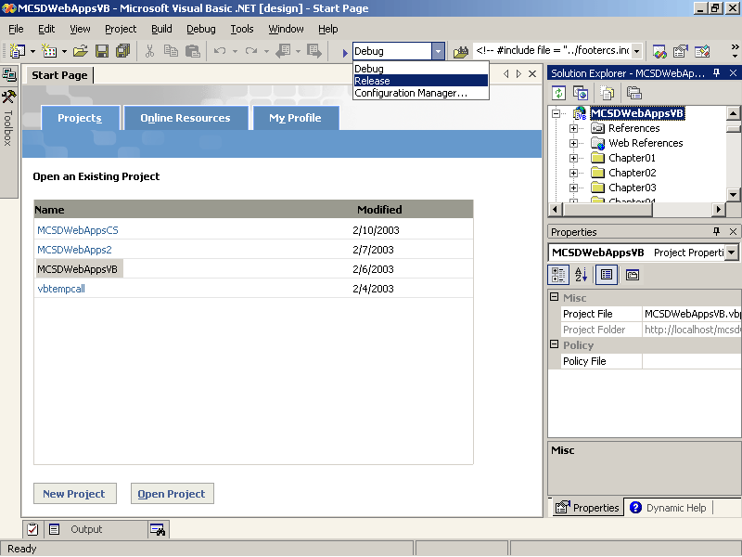
Figure 9-1. Selecting the build configuration in the toolbar
- From the Project menu, select Properties. Visual Studio displays the project Properties Pages dialog box, as shown in Figures 9-2 and 9-3.
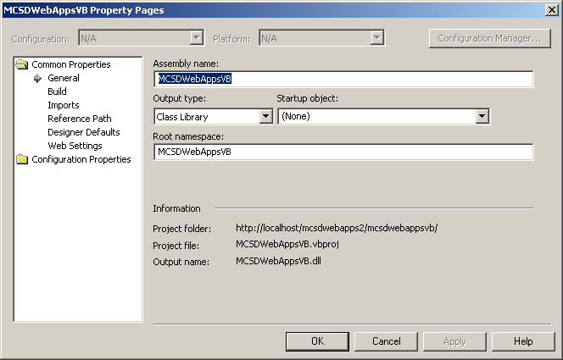
Figure 9-2. Project Property Pages dialog box (Visual Basic .NET)
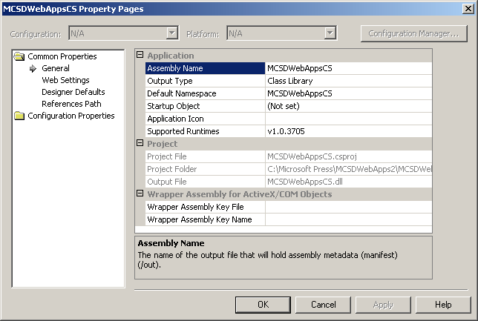
Figure 9-3. Project Property Pages dialog box (Visual C#)
The Common Properties and Configuration Properties folders in the project Property Pages dialog box allow you to set the build properties used when compiling the project. These options are found in different places for Microsoft Visual Basic .NET and Microsoft Visual C# projects, as described in Tables 9-1 and 9-2.
Table 9-1. Key Project Build Options (Visual Basic .NET)
Task | Folder and item | Set to
Make the project compatible with an earlier Microsoft .NET Framework version (Visual Studio version 1.1 and later). | Common Properties, Build, Supported Runtimes | On the Build page, click Change to open the .NET Framework Version dialog box, and select support for earlier versions of the .NET Framework, such as 1.0.3075.
Optimize the compiled code. | Configuration Properties, Optimizations | Select the Enable Optimizations check box to make the compiled code smaller, faster, and more efficient. Selecting this option makes debugging more difficult, however.
Disable integer overflow checks. | Configuration Properties, Optimizations | Select the Remove Integer Overflow Checks check box to perform integer calculations without checking for division by zero or overflow conditions. This is faster at run time but prevents these errors from being raised at run time.
Allow classes to be used from the Component Object Model (COM). | Configuration Properties, Build | Select the Register For COM Interop check box to generate a type library and register the application in the system registry. This option has an effect only on Class Library project types.

Table 9-2. Key Project Build Options (Visual C#)
Task | Folder and item | Set to
Make the project compatible with an earlier .NET Framework version (Visual Studio version 1.1 and later). | Common Properties, General, Applicaton, Supported Runtimes | Click the ellipsis (…) button to open the .NET Framework Version dialog box, and select support for earlier versions of the .NET Framework, such as 1.0.3075.
Optimize the compiled code. | Configuration Properties, Build, Code Generation, Optimize Code | Select True to make the compiled code smaller, faster, and more efficient. Selecting True makes debugging more difficult, however.
Disable integer overflow checks. | Configuration Properties, Build, Code Generation, Check For Arithmetic Overflow/Underflow | Select False to perform integer calculations without checking for division by zero or overflow conditions. This is faster but prevents these errors from being raised at run time.
Allow the use of the unsafe keyword. | Configuration Properties, Build, Code Generation, Allow Unsafe Code Blocks | Select True to allow the project to use pointers within procedures defined with the unsafe keyword.
Allow classes to be used from COM. | Configuration Properties, Build, Outputs, Register For COM Interop | Select True to generate a type library and register the application in the system registry. This option affects only Class Library project types. It is disabled for Web applications.
- Open the project’s Web.config file and set the compilation element to match the build setting you selected in step 1. For example, use the following setting for a release build:
<compilation defaultLanguage="vb" debug="false" />
Selecting the debug build option generates a program database file (.pdb) containing information about symbols used within the application when the project is compiled. Visual Studio .NET uses the program database to monitor the values of variables, set breakpoints, and evaluate Debug class members.
Selecting the release build option does not generate this file; this disables Debug class members and causes breakpoints to be ignored. Because release builds don’t have to monitor this extra information, they execute faster than debug builds.
The application’s build option and Web.config setting should agree. There is no advantage in having one set to debug and the other set to release; however, Visual Studio .NET does not automatically change one when you change the other.
Identifying the Application
Before you deploy an application, you should include information about the application such as the application’s title, author, and version. This information is displayed when the user views the version properties of the application’s assembly (.dll) from within Microsoft Windows, as shown in Figure 9-4.
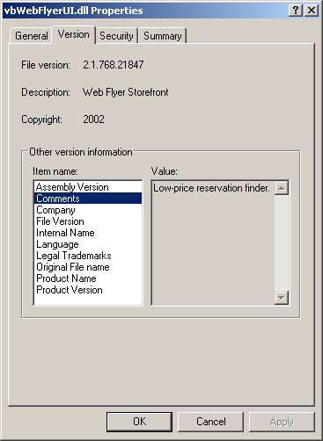
Figure 9-4. Assembly properties
To identify your application, open the AssemblyInfo file and enter the application’s information in the assembly attributes. For example, the following attributes set the product name and version information shown in Figure 9-4:
Visual Basic .NET
Imports System.Reflection
Imports System.Runtime.InteropServices

' General Information about an assembly is controlled through the following
' set of attributes. Change these attribute values to modify the information
' associated with an assembly.

' Review the values of the assembly attributes.

<Assembly: AssemblyTitle("Web Flyer Storefront")>
<Assembly: AssemblyDescription("Low-price reservation finder.")>
<Assembly: AssemblyCompany("Contoso Ltd. ")>
<Assembly: AssemblyProduct("Web Flyer")>
<Assembly: AssemblyCopyright("2002")>
<Assembly: AssemblyTrademark("Web Flyer is a trademark of Contoso Ltd.")>
<Assembly: CLSCompliant(True)>

' The following GUID is for the ID of the typelib if
' this project is exposed to COM
<Assembly: Guid("CE84F243-D7D9-4B7E-B43B-520A0D6B9B30")>

' Version information for an assembly consists of the following four values:
'
' Major Version
' Minor Version
' Build Number
' Revision
'
' You can specify all the values or you can default
' the Build and Revision Numbers by using
' the '*' as shown below:

<Assembly: AssemblyVersion("2.1.*")>
Visual C#
using System.Reflection;
using System.Runtime.CompilerServices;

//
// General Information about an assembly is controlled through the following
// set of attributes. Change these attribute values to modify the information
// associated with an assembly.
//
[assembly: AssemblyTitle("Web Flyer Storefront")]
[assembly: AssemblyDescription("Low-price reservation finder.")]
[assembly: AssemblyConfiguration("")]
[assembly: AssemblyCompany("Contoso Ltd.")]
[assembly: AssemblyProduct("Web Flyer")]
[assembly: AssemblyCopyright("2002")]
[assembly: AssemblyTrademark("Web Flyer is a trademark of Contoso Ltd.")]
[assembly: AssemblyCulture("")]

//
// Version information for an assembly consists of the following four values:
//
// Major Version
// Minor Version
// Build Number
// Revision
//
// You can specify all the values or you can default the Revision and Build
// Numbers by using the '*' as shown below:

[assembly: AssemblyVersion("2.1.*")]
Two pieces of information are automatically generated for you in the AssemblyInfo file:
- The Guid attribute is generated by Visual Studio .NET to identify the assembly to COM components. You need to change this number only if you break compatibility with earlier versions of the assembly by removing or significantly changing public objects and members that are used by COM components.
- The AssemblyVersion attribute automatically updates the build version number, indicated by the asterisk (*). You can add levels of versioning or remove the build number if you want.
Configuring the Application
Web applications use text configuration files (.config) to specify how they run. A Web application’s configuration file (Web.config) resides in the Web application’s root directory, but that file’s function is really to override the settings inherited from the following locations:
- The Machine.config file located in the Windows\Microsoft.NET\Framework\version\config directory
This sets the base configuration for all .NET assemblies running on the server.
- The Web.config file located in the IIS root directory
This sets the base configuration for all Web applications and overrides settings in Machine.config.
- Any Web.config files in the current application’s parent directories
These settings are inherited from Web.config files along the application’s path.
The Web.config file uses Extensible Markup Language (XML) elements to control different aspects of the Web application, as described in Table 9-3. Because these elements use XML syntax, they are case sensitive and must be typed exactly as shown.
Table 9-3. Web.config Attributes
Element | Use to | For more information, see
compilation | Set the build type to debug or release | “Setting Build Options,” earlier in this lesson
customErrors | Display custom error pages in response to HTTP response codes | Chapter 6, “Catching and Correcting Errors”
authentication | Set the type of authentication to use to identify users | Chapter 8, “Maintaining Security”
authorization | List user names or user roles that are authorized to run the application | Chapter 8, “Maintaining Security”
Trace | Enable tracing to help diagnose errors or tune performance | Chapter 6, “Catching and Correcting Errors”
sessionState | Determine how Microsoft ASP.NET stores Session state variables | Lesson 3 in this chapter, and Chapter 3, “Working with Web Objects”
globalization | Set cultural information for localized applications | Chapter 15, “Globalizing Web Applications”
When you make changes to an application’s Web.config file, IIS automatically restarts the application and applies the changes. This has the side effect of resetting current Application or Session state variables, which can adversely affect users.
For security reasons, you can’t access the Web.config file from a browser. If a user requests the Web.config file from your Web site, he or she will receive an access denied error message.
Lesson 2: Deploying a Web Application
Deploying a Web application means installing the application on the server where it will run. Because they run on servers, Web applications might not require an installation program. Instead, they can simply be uploaded to the Web server using the Visual Studio upload tools.
In this lesson, you’ll learn how to deploy a completed Web application to a hosting service or to your own server. You’ll also learn about IIS and security settings required by Web applications. This lesson does not cover creating an installation program for a Web application; for information about that task, see Lesson 3.
After this lesson, you will be able to
- Upload a completed Web application to a hosting service
- Create a virtual folder in IIS to host a Web application on your own server
- Copy a Web application to a virtual folder on your own server
- Install COM and .NET components used by your Web application
- Assign security privileges to the ASPNET user account
Estimated lesson time: 15 minutes
Using the Upload Tools
If you signed up with an ASP.NET host service, as described in Chapter 1, “Introduction to Web Programming,” you can install your Web application on the host’s servers directly from Visual Studio .NET.
To install your application on a hosting service from Visual Studio .NET, follow these steps:
- Open the project you want to install using Visual Studio .NET.
- On the Online Resources tab on the Visual Studio .NET Start Page, click Web Hosting.
- On the Web Hosting page, click the Premier Providers or Additional Providers tab.
- In the section of the providers page that lists your host, click Upload Directly To Your Account. Visual Studio .NET displays your host’s upload page, as shown in Figure 9-5.
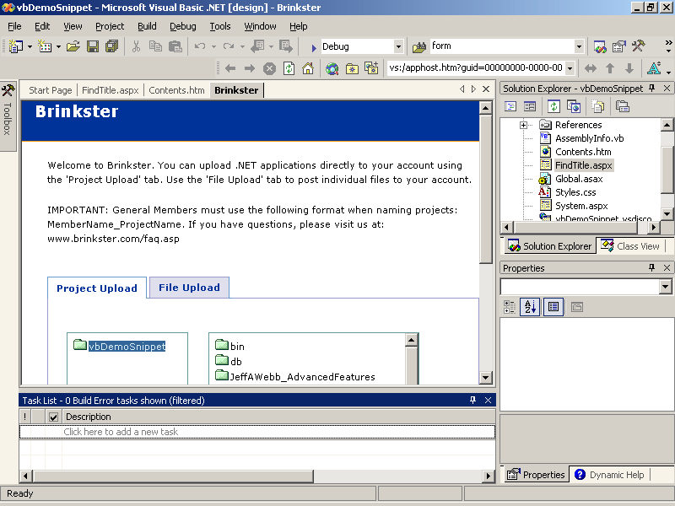
Figure 9-5. Uploading a Web application
- Follow the upload instructions on the host’s page. These instructions vary slightly among the different host services.
Hosting on Your Own Server
If your application is intended to run as part of a local network or if you have access to your own public Web server, install your application on the server by following these steps:
- Use IIS to set up a virtual folder for the application.
- Copy the Web application to the virtual directory.
- Add any shared .NET components to the server’s global assembly cache (GAC).
- Set the security permissions on the server to allow the application to access required resources.
The following sections describe these steps in more detail.
Setting Up a Virtual Folder
ASP.NET Web applications run under IIS, so both IIS and the Microsoft .NET Framework must be installed on the server before that server can host Web applications. ASP.NET requires the following component versions:
- IIS version 5.0 or later.
- The .NET Framework using the same version number as you used to compile the Web application’s assembly.
The Visual Studio .NET distribution disks include tools for setting up the required server components. When you have confirmed that the correct components are installed on the server, create a virtual folder for the application on the server by following these steps:
- Using Windows Explorer, create a physical folder on the server to store the application.
- Using IIS, start the Virtual Directory Creation Wizard to create the new virtual folder for the physical location created in step 1. Detailed instructions on using this wizard are covered in Chapter 2, “Creating Web Forms Applications.”
Copying the Application
Web application boundaries are defined by the application’s directory structure. That means that an application starts at its root folder and extends to all of its subordinate folders. This makes installing a Web application as easy as dragging the application’s files and subfolders from its development directory to its physical location on the server.
In general, a Web application’s content files can be organized into subfolders any way you want. However, you should follow a couple of conventions:
- The application’s assembly (.dll) is stored in the /bin subfolder.
- The start page for the application is generally named Default.aspx or Default.htm.
Whether or not your application uses a default start page is determined by settings in IIS. A default page enables IIS to display a page if the user does not specify one in his or her request. For example, a user might make a request using only your domain name, such as http://www.contoso.com. If a default page is enabled, IIS will respond with http://www.contoso.com/default.aspx.
NOTE
Don’t confuse IIS default pages with the Web Forms application start page in Visual Studio .NET. Visual Studio .NET requires that you set a start page for each project so that the development environment knows which page to display first during debugging. This setting has no effect on the IIS default page settings.
Installing Shared Components
If your application uses components that are shared with other applications on the server, such as custom server controls, those components must be installed on the server. There are three ways to do this, depending on the type of component:
- For COM components
Copy the component to the server and register the component using the COM registration tools.
- For weak-named .NET components
Copy the component to the application’s /bin directory.
- For strong-named .NET components
Install the component in the server’s GAC.
COM components generally provide a setup program to install or remove them from the system. If the component doesn’t provide a setup program, you can copy it to the server and register it using the MFC RegSvr32.exe utility, as shown here:
RegSvr32 MyComp.dll
.NET component names come in two flavors: weak and strong. This distinction refers to how the names are stored within the assembly. Weak names are not guaranteed to be unique and thus cannot be shared without potentially causing conflicts. Strong names are digitally signed and provide a public key that ensures there are no conflicts. Furthermore, .NET components with strong names can’t call unmanaged code (such as COM components) and thus avoid potential conflicts with dependencies.
Weak-named .NET components must be individually copied to the /bin directories of the Web applications where they are used. Strong-named .NET components can be copied into the server’s GAC, as shown in Figure 9-6.
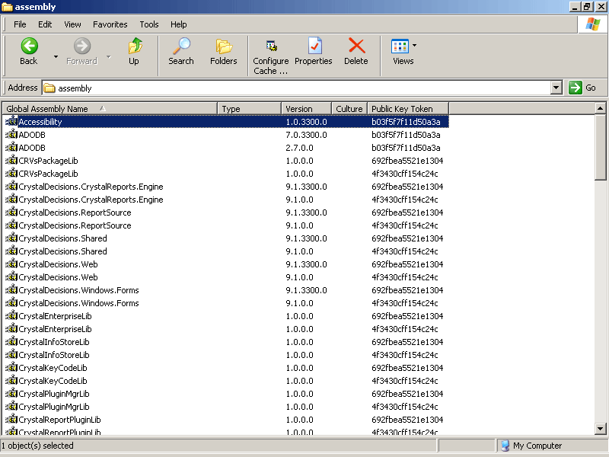
Figure 9-6. Viewing .NET components in the global assembly cache
The global assembly cache (GAC) is a special subfolder within the Windows folder that stores the shared .NET components. When you open the folder, Windows Explorer starts a Windows shell extension called the Assembly Cache Viewer (ShFusion.dll), as shown in Figure 9-6.
You can install strong-named .NET components by dragging them into the Assembly Cache Viewer, or by using the Global Assembly Cache tool (GacUtil.exe), as shown here:
GacUtil –i MyServeControls.dll
Assigning Security Privileges
By default, the ASP.NET worker process runs using the ASPNET account, which is created when you install the .NET Framework. This account has limited privileges, which can cause permission-denied errors if your application writes files or tries to read files outside the current Web application’s boundaries.
If your application requires additional permissions, you have three options:
- Grant the ASPNET user access to the required files. To use this option, the server must be using the Windows NT file system (NTFS).
- Change the group the ASPNET user belongs to.
- Use impersonation to run the process as another user.
To grant the ASPNET user access to a file or folder, follow these steps:
- In Windows Explorer, choose Folder Options from the Tools menu. Windows Explorer displays the Folder Options dialog box.
- In the Folder Options dialog box, click the View tab, and clear the Use Simple File Sharing check box at the bottom of the Advanced Settings list, as shown in Figure 9-7. Click OK to make the change and close the dialog box.
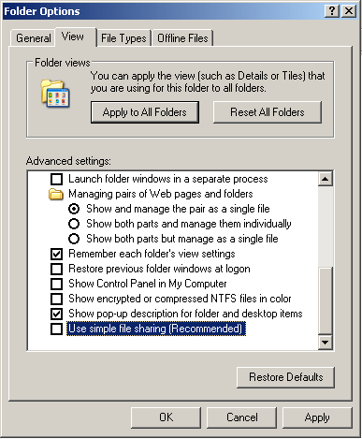
Figure 9-7. Enabling full file permissions
- In Windows Explorer, right-click the file or folder you want to grant access to, and select Properties on the shortcut menu. Windows Explorer displays the Properties dialog box.
- Click the Security tab, and then click Add to add the ASPNET user to the Group Or User Names list, as shown in Figure 9-8.
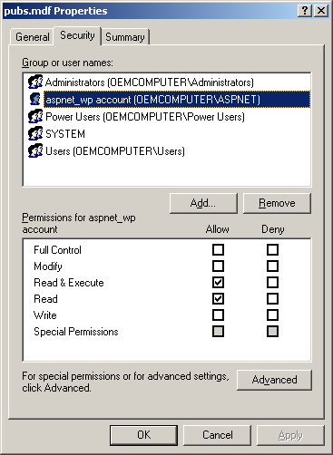
Figure 9-8. Adding the ASPNET user account
- Select the check boxes in the permissions list to grant the required access. Click OK to make the changes and close the dialog box.
To change the group the ASPNET user account belongs to, follow these steps:
- From the Start menu, point to All Programs, Administrative Tools, and then choose Computer Management. Windows displays the Computer Management console.
- Expand Local Users And Groups in the console tree, and then select Users, as shown in Figure 9-9.
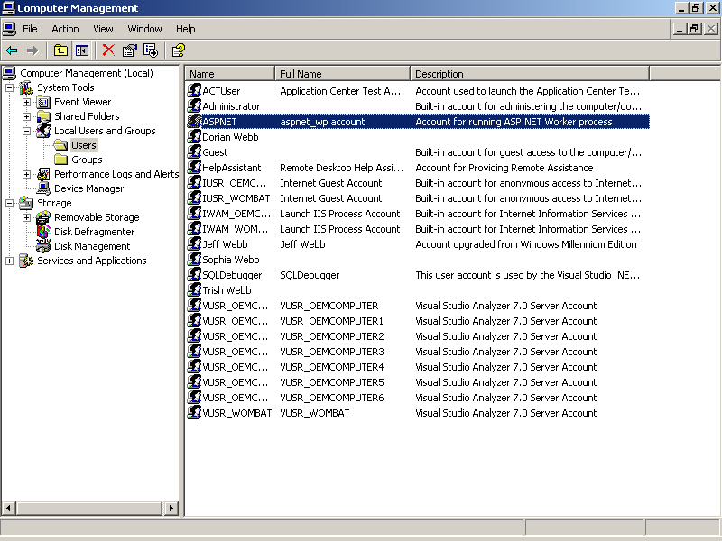
Figure 9-9. Modifying the ASPNET user account
- Right-click the ASPNET user account, and select Properties on the shortcut menu. The Computer Management console displays the Properties dialog box for the ASPNET account, as shown in Figure 9-10.
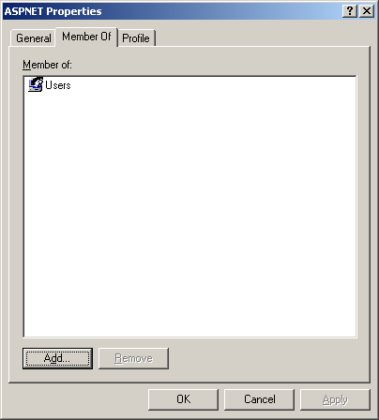
Figure 9-10. Adding a group to ASPNET
- Click the Member Of tab, and then click Add to open the Select Groups dialog box to add the ASPNET user to a new group. Click OK to make the changes and close the dialog boxes.
Adding the ASPNET user to the Administrators group gives your Web application full privileges on the server; however, it also poses a potential security risk because outside users might be able to manipulate your application to hack your server.
To use impersonation to run the ASP.NET process as a user other than ASPNET, set the identity element’s impersonation attribute in the application’s Web.config file. For example, the following entry sets the application to run as the WebFlyr user account:
<identity impersonate="true" name="localhost\WebFlyr" password="hpB14dQi" />
If your application uses Windows authentication, you can also use impersonation to pass the identity of authenticated users through to the server. For example, the following Web.config fragment tells the application to use the permissions of the user who signed on to the application:
<identity impersonate="true" /> <!-- Use impersonation. -->

<authorization>
<deny users="?" /> <!-- Require authentication. -->
</authorization>
For more information about authenticating users, see Chapter 8, “Maintaining Security.”
Lesson 3: Creating an Installation Program
If you’re installing a Web application on multiple servers or if the servers are located on secure networks that do not allow you to deploy the application using Visual Studio’s upload tools, you’ll have to create an installation program for your application.
In this lesson, you’ll learn how to create an installation program for a Web application that runs from the Web or from a CD-ROM. You’ll also learn how to add shared components to that installation program through merge modules.
After this lesson, you will be able to
- Create a Setup and Deployment project for a Web application
- Add multiple IIS application folders to a project
- Create an installation program for use over the Web
- Create an installation program for use from a CD-ROM
- Add shared components to a Setup and Deployment project
Estimated lesson time: 30 minutes
Creating a Setup and Deployment Project
The easiest way to create an installation program for a Web application is to use the Setup And Deployment Projects’ Setup Wizard template. To create a new Setup And Deployment project for a Web application, follow these steps:
- Open the solution containing your Web application in Visual Studio.
- From the File menu, point to Add Project, and then choose New Project. Visual Studio displays the Add New Project dialog box, as shown in Figure 9-11.
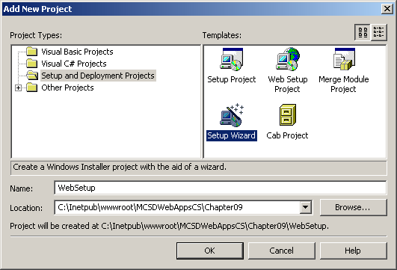
Figure 9-11. The Add New Project dialog box
- Select Setup And Deployment Projects in the Project Types list, and select Setup Wizard from the Templates list. Type the name of the setup project to create, and click OK to begin the wizard. Visual Studio uses the project name as the name of the root virtual folder to create on the server.
- Click Next on the wizard’s Welcome page, select Create A Setup For A Web Application on the Choose A Project Type page, and click Next. Visual Studio displays the Choose Project Outputs To Include page, as shown in Figure 9-12.
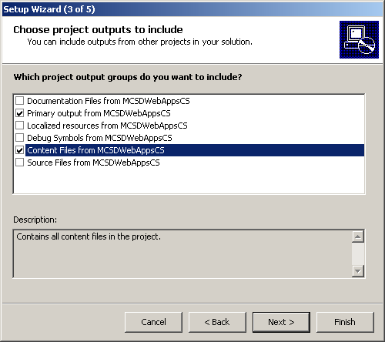
Figure 9-12. The Setup Wizard Choose Project Outputs To Include page
- Select the project output that you want to install on the server. For a Web application, you must select at least the primary output and content files for your project. Primary output refers to the application’s assembly; content files refers to the project’s Web forms, HTML pages, user controls, configuration files, and other content used by a Web application. Click Next; Visual Studio displays the Choose Files To Include page, as shown in Figure 9-13.
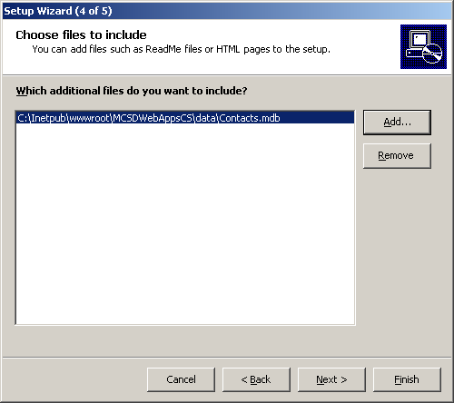
Figure 9-13. The Setup Wizard Choose Files To Include page
- Click Add to open the Add Files dialog box, and select the files that are used by the Web application but are not included as part of the Web application project, such as Microsoft Access database files, text files, and so on. After adding the necessary files, click Next; Visual Studio displays the Create Project page, as shown in Figure 9-14.
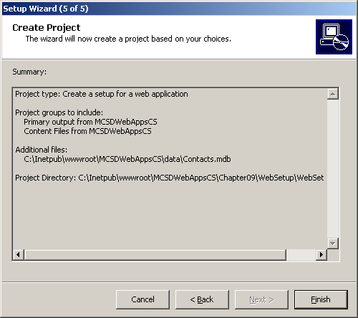
Figure 9-14. The Setup Wizard Create Project page
- Click Finish to create the setup project and add it to the current solution. When complete, the setup project appears as shown in Figure 9-15.
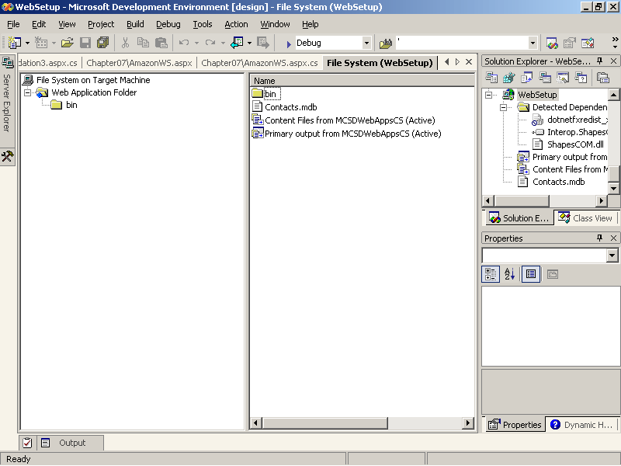
Figure 9-15. The completed setup project
By default, the Setup Wizard creates a project for installation from removable media, such as a CD-ROM. When built, this project writes the Windows Installer (Setup.exe), an initialization file (Setup.ini), and a content file (projectname.msi) to the /debug or /release folder of the setup project’s folder.
In most cases, you’ll need to take the following additional steps before building and deploying the setup project:
- Change the setup project options to support Web deployment:
- Review the setup project output and add needed files.
- Rename the root virtual folder where your application will be installed.
- Add virtual folders to create additional IIS application starting points on the target server.
- Include shared .NET components to install in the server’s GAC or shared COM components to install and register with the server’s system registration database.
The following sections describe how to perform these steps.
Modifying the Setup Project for Web Deployment
The Visual Studio setup projects generate an installation program that uses the Windows Installer bootstrap executable (Setup.exe). This executable checks whether the target machine has the Windows Installer, prompts the user to download the Installer if it is not installed, and starts the Installer once it is available. By default, the Setup Wizard uses a bootstrap executable configured for local access to the setup resources, as when distributing the software on a CD-ROM.
To create a setup project that can be installed from an Internet address, follow these steps:
- Select the setup project in Solution Explorer, and choose Properties from the Project menu. Visual Studio displays the setup project Property Pages dialog box, as shown in Figure 9-16.
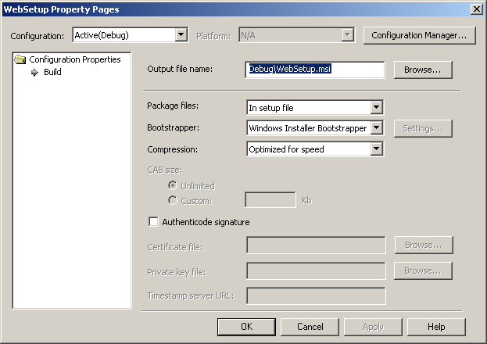
Figure 9-16. Setup project properties
- Select Web Bootstrapper from the Bootstrapper drop-down list. Visual Studio displays the Web Boostrapper Settings dialog box, as shown in Figure 9-17.
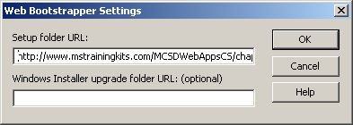
Figure 9-17. Web Bootstrapper settings
- In the Setup Folder box, type the Web address where you will deploy the installation program and click OK. Then click OK to close the Property Pages dialog box.
- Build the setup project, and copy the Setup.exe and projectname.msi files to the Web address specified in step 3.
- Add a Web page with a link to the Setup.exe file specified in step 3. For example, the following link installs the Web application from the WebApps\Install folder:
- <a href="http://www.contoso.com/WebApps/Install/Setup.exe">Install Web
Applicaton</a>
Reviewing the Setup Project’s Contents and Adding Files
As mentioned, Web application setup projects must include at least the primary project output (the assembly) and the content files (Web forms and so on). Setup automatically creates the /bin folder and any subordinate folders for content files based on the source project’s content.
To review the content before building a setup project, perform the following task:
- Right-click the output item in the setup project’s File System window, and select Output from the shortcut menu. Visual Studio displays the content items, as shown in Figure 9-18.
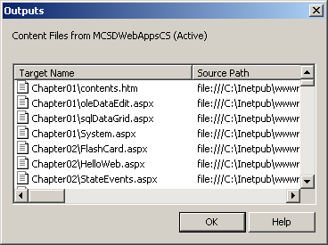
Figure 9-18. Viewing content output
The Outputs dialog box displays the source and destination locations of each item to install. Sometimes items in the source project don’t appear in the Outputs list as you might expect. In those cases, select the item in the source project and verify that its Build Action property is set to Content.
Other times, you might want to include files in the setup project that aren’t part of the source project. For example, you might want to install a Microsoft Access database in a data folder along with the rest of your Web application.
To add files to the setup project other than source files, follow these steps:
- Right-click in the setup project’s File System window, point to Add, and select File from the shortcut menu. Visual Studio displays the Add Files dialog box.
- Select the files to add, and click OK to add them to the setup project’s File System window.
Renaming and Adding Virtual Folders
The Setup Wizard creates one virtual folder to be installed as an application folder in IIS. This folder appears on the right side of the File System editor and is named Web Application Folder. The Setup Wizard gives this virtual folder the setup project’s name. This will be the Web application’s root folder when installed on the server, so you’ll probably want to rename it.
To change the name of the root virtual folder to install, follow these steps:
- Select the Web Application Folder in the File System editor.
- In the Properties window, set the VirtualDirectory property.
Some Web applications include multiple application starting points within their folder structure. In Visual Studio, you create a new application starting point by adding a new Web application project. Each Web application project has its own root virtual folder containing Web.config and Global.asax files. To get Setup to create IIS application folders for these projects, you must add a custom Web folder to the setup project.
To add a custom Web folder to a setup project, follow these steps:
- Right-click the File System On Target Machine item in the File System editor, point to Add Special Folder, and then select Web Custom Folder from the shortcut menu. Enter a name for the new folder.
- Set the VirtualDirectory property of the Web folder to reflect the structure of your application. Use the relative address to create the folder within another application’s domain. For example, MainApp/Restricted creates the folder Restricted within the MainApp virtual folder.
- Add project output to the new Web folder as you did in the preceding section, “Reviewing the Setup Project’s Contents and Adding Files.”
Adding Shared Components
Components used by more than one application should have their own, separate setup projects called merge modules. Merge modules allow the server to manage the installation of shared components so that they’re not unnecessarily overwritten and so that they can be safely removed when no longer used. Unlike regular setup projects, merge modules can’t be installed by themselves—they can be installed only as part of an application installation.
To create a merge module, follow these steps:
- From the Visual Studio File menu, point to New, select Project, and then select the Merge Module Project in the New Project dialog box.
- In the setup File System editor, add the components to install. You can add special folders to the File System editor to add components to the server’s System folder, GAC, or other shared locations.
- Build the project. Visual Studio generates a merge module (projectname.msm) once the merge module is built.
To add a merge module to a setup project, follow these steps:
- Open the setup project in Visual Studio.
- From the Project menu, point to Add, and choose Merge Module. Visual Studio displays the Add Modules dialog box.
- Select the merge module to add, and click OK.
Lesson 4: Maintaining a Deployed Application
After you have deployed a Web application, you need to monitor how it performs on the server. Many issues can crop up at this point because of the number of users accessing the application, the unpredictable nature of user interaction, and the possibility of malicious attack.
Maintaining a deployed application is an ongoing task that involves three major steps:
- Monitoring the application for error, performance, and security issues
- Repairing the application as issues are discovered
- Tuning the application to respond to user traffic
In this lesson, you’ll learn how to perform these tasks, as well as learn about some optimization techniques.
After this lesson, you will be able to
- Use the Windows tools to monitor application errors, security, and performance on the server
- Create alerts to notify you when a problem occurs
- Chart performance and monitor activity using event logs
- Repair a deployed application by replacing the assembly or content files
- Use the server’s configuration settings to control how ASP.NET applications maintain their processes
- Evaluate how programming techniques and ASP.NET features affect performance
Estimated lesson time: 20 minutes
Monitoring the Server
After your application is deployed, you need to monitor the server where it is running to help detect and correct problems related to security, performance, and unanticipated errors. Windows provides the following MMC snap-ins for monitoring security, performance, and error events:
- The Event Viewer snap-in
Lists application, system, and security events as they occur on the system. Use this tool to see what is currently happening on the server and to get specific information about a particular event.
- The Performance snap-in
Lets you create new events to display in the Event Viewer and allows you to track event counters over time for display graphically or in report form.
The following sections describe how to use these tools in more detail.
Viewing Events
Use the MMC Event Viewer snap-in to view application, system, and security events as they happen.
To run the Event Viewer, choose Event Viewer from the Administrative Tools submenu on the Windows Start menu. (You can show the Administrative Tools menu in Windows XP Professional by opening the Start button’s Properties dialog box and clicking the Customize button on the Start Menu tab. The Administrative Tools option is located on the Advanced tab of the Customize Start Menu dialog box.) After clicking the Event Viewer shortcut, Windows displays the Event Viewer snap-in in the MMC, as shown in Figure 9-19.
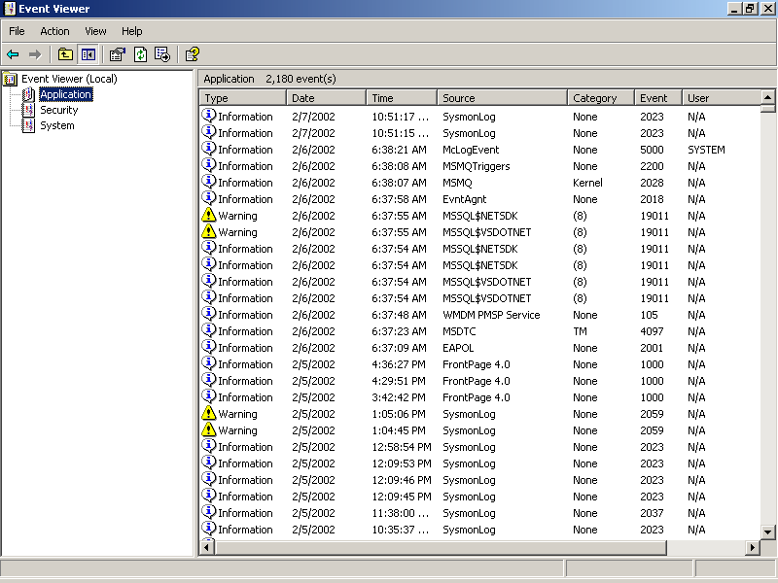
Figure 9-19. Viewing events
The Event Viewer snap-in displays general application, system, and security events at three levels: informational events, warning events, and error events.
To view information about a specific event, double-click the event. The snap-in displays the Event Properties dialog box, as shown in Figure 9-20.
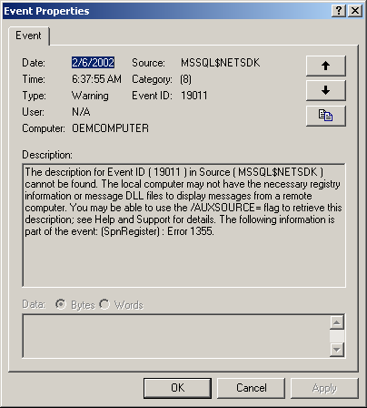
Figure 9-20. Viewing event details
You can use the Event Viewer to get a snapshot of what is happening on the server or to get details about a particular event. To create new events or to track events over time, you need to use the MMC Performance snap-in, as described in the following sections.
Defining New Events
In many cases, the standard system, application, and security events don’t tell you what you really want to know. For example, you might want to know when the number of users connected to a Web application exceeds 1000 or when an unhandled exception occurs within the Web application. To add events such as these to your counter and trace logs, use the MMC Performance snap-in.
To run the Performance snap-in, choose Performance from the Administrative Tools submenu on the Windows Start menu. Windows displays the Performance snap-in, as shown in Figure 9-21.
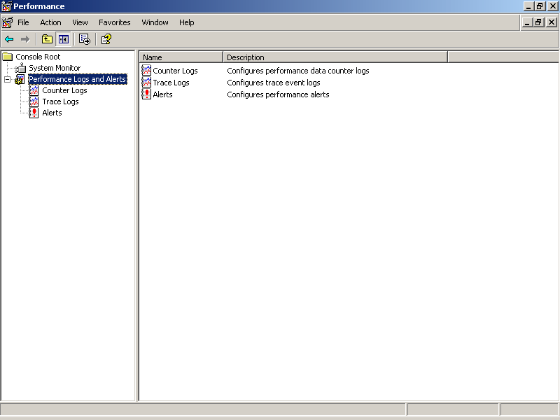
Figure 9-21. Adding events to monitor
The Performance snap-in allows you to create log files that record activity on the server and to create alerts that raise events in the Event Viewer. Using this tool, you can monitor a wide variety of information about the server, the applications it is hosting, and the users connected to it.
Perhaps the best way to understand how this works is to walk through adding an event to monitor on your own system, as described in the following steps:
- From the Performance window, select Alerts from the Performance Logs And Alerts list in the left pane.
- From the Action menu, choose New Alert Settings. The snap-in displays the New Alert Settings dialog box, as shown in Figure 9-22.
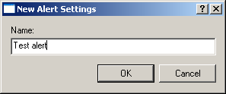
Figure 9-22. Naming a new alert
- Type a name for identifying the alert, and click OK. The snap-in displays the new Alert dialog box, as shown in Figure 9-23.
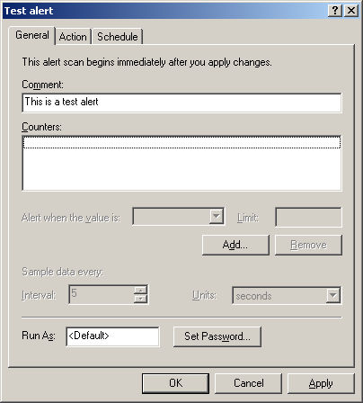
Figure 9-23. Setting alert properties
- Add an event to monitor by clicking Add. The snap-in displays the Add Counters dialog box, as shown in Figure 9-24.
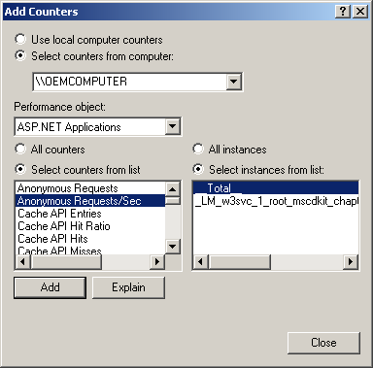
Figure 9-24. Adding counters to monitor ASP.NET users
- Select the hardware item or application to monitor from the Performance Object drop- down list. The snap-in updates the counters list with items that apply to the selected Performance object. Click Add to add the selected counter to the alert. Click Close when you’ve finished.
- Set the criterion that raises the alert in the new Alert dialog box by typing a number in the Limit box.
For example, Figure 9-25 shows settings to raise the alert when the ASP.NET user count exceeds 1000.
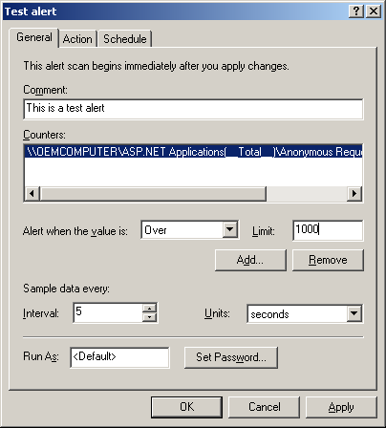
Figure 9-25. Setting a criterion to raise the alert
- Click the Action tab to specify what the server should do when the alert is raised. By default, the server records the alert as an event that can be viewed from the Event Viewer. You can also send the alert as an e-mail or write the alert to a log file, as shown in Figure 9-26.
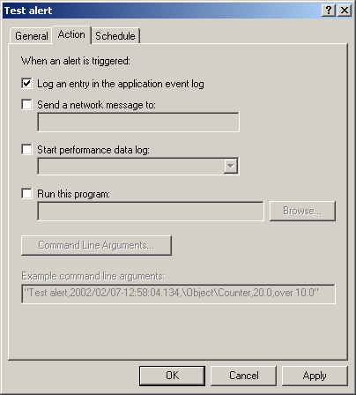
Figure 9-26. Specifying the action to take
- When you have finished, click OK. The snap-in adds the alert to the Alerts list, as shown in Figure 9-27.
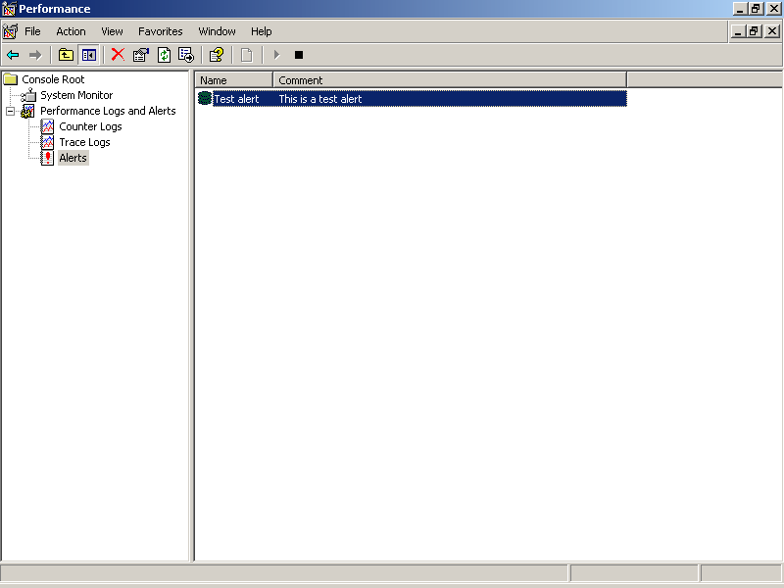
Figure 9-27. The new alert
By default, the snap-in starts monitoring the new alert immediately. You can stop or restart monitoring the alert by right-clicking the alert and choosing Stop or Start from the shortcut menu.
Windows raises the alert whenever the alert criterion is met. For some counters, such as error counts, this means that after the alert is raised the first time, it is raised after every interval. Because the error count is not automatically reset, it always exceeds the count limit when the limit is met. For these types of alerts, you should be careful what action you specify—sending an e-mail in response to an error count alert can result in a lot of redundant mail messages.
Creating Event Logs
Defining a new event by creating an alert is a good way to be notified the moment a problem occurs or when a performance has degraded, but to track errors and performance over time, you must create an event log. Event logs let you gather information about a wide variety of events over time and then display that information graphically or in text form.
To create an event log, follow these steps:
- From the Performance window, select Counter Logs from the Performance Logs And Alerts list in the console tree.
- From the Action menu, choose New Log Settings. The snap-in displays the New Log Settings dialog box, as shown in Figure 9-28.
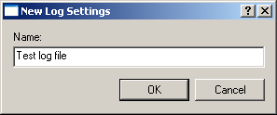
Figure 9-28. Naming a new log file
- Type the name of the log, and click OK. The snap-in displays the log file’s properties dialog box, as shown in Figure 9-29.
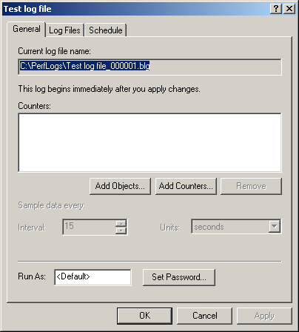
Figure 9-29. Setting log properties
- Click Add Objects or Add Counters to add items to track within the log file. The snap-in displays the Add Counters dialog box, as shown in Figure 9-30. These counters work the same way they do for alerts.
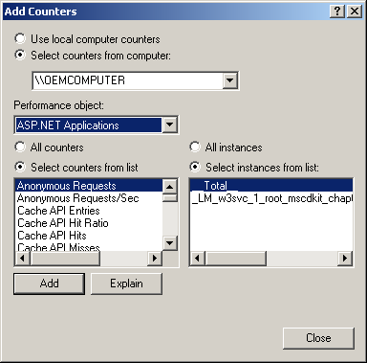
Figure 9-30. Adding counters to record
- Click the Log Files tab to specify the format of the log file to create. The snap-in displays the Log Files properties, as shown in Figure 9-31.
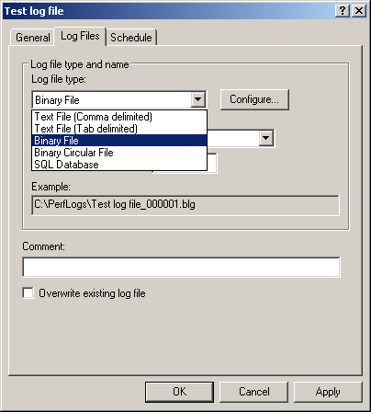
Figure 9-31. Specifying log file format
- Log files can be saved in binary, text, or database formats. Click OK when you’ve finished. The snap-in adds the log to the Counter Logs list, as shown in Figure 9-32.
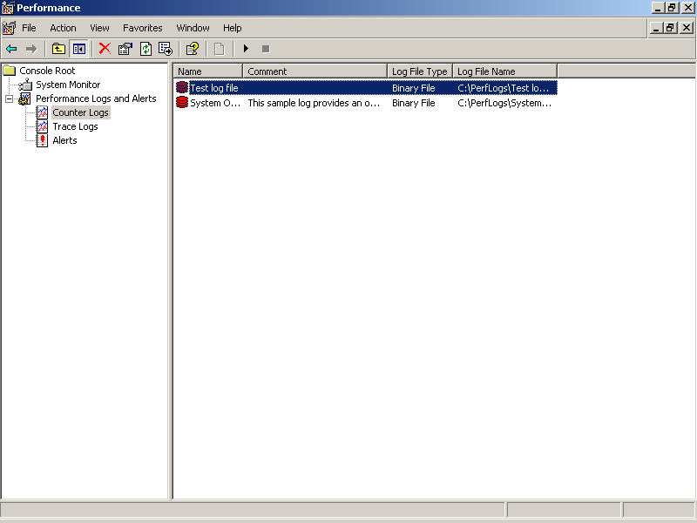
Figure 9-32. The new log
As with alerts, the snap-in starts monitoring the new log immediately. You can stop or restart monitoring the log by right-clicking the log and choosing Stop or Start from the shortcut menu.
Viewing Event Logs
By default, the Performance snap-in saves log files to the PerfLogs root folder. To view the log file from within the snap-in, follow these steps:
- From the Performance window, select System Monitor from the console tree. The snap-in displays the system monitor with the current performance statistics, as shown in Figure 9-33.
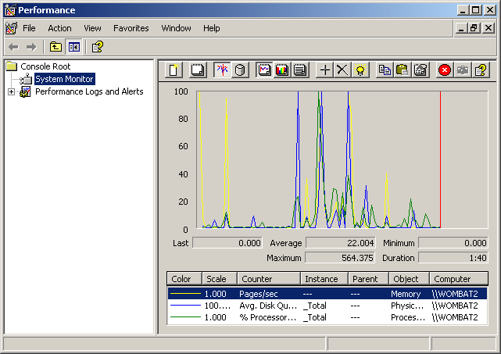
Figure 9-33. Current CPU, memory, and disk usage statistics
- Click the View Log Data toolbar button. The snap-in displays the System Monitor Properties dialog box, as shown in Figure 9-34.
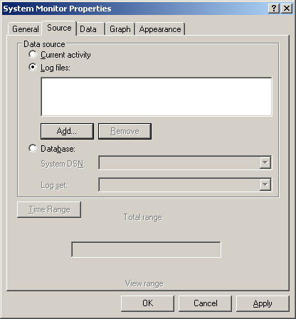
Figure 9-34. System Monitor Properties dialog box
- Select Log Files, and click Add to specify a file to open. The snap-in displays the Select Log File dialog box, as shown in Figure 9-35.
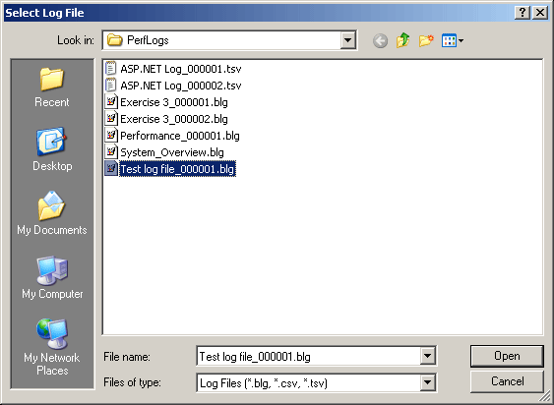
Figure 9-35. Opening a log file
- Select a log file to open from the PerfLogs folder, and click Open to add it to the monitor.
- Click the Data tab in the System Monitor Properties dialog box to add items from the log to the chart, as shown in Figure 9-36.
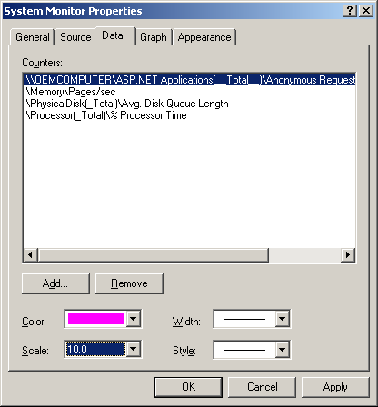
Figure 9-36. Adding items to chart
- Click OK to close the System Monitor Properties dialog box. The snap-in displays the log file, as shown in Figure 9-37.
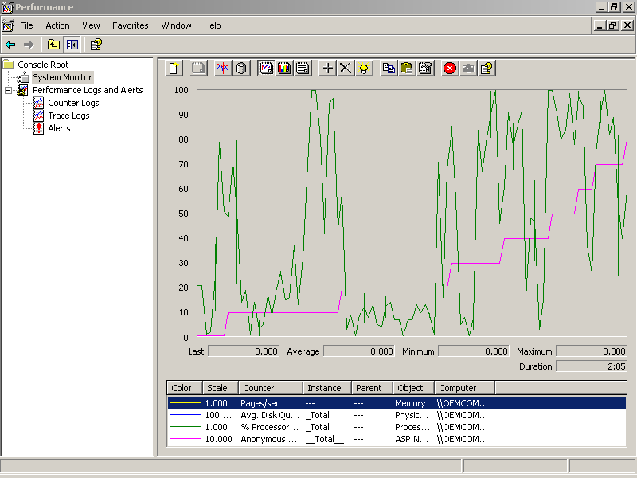
Figure 9-37. Viewing a log file in chart form
- Click the View Report toolbar button to view the data as text rather than graphically. The System Monitor displays the text view, as shown in Figure 9-38.
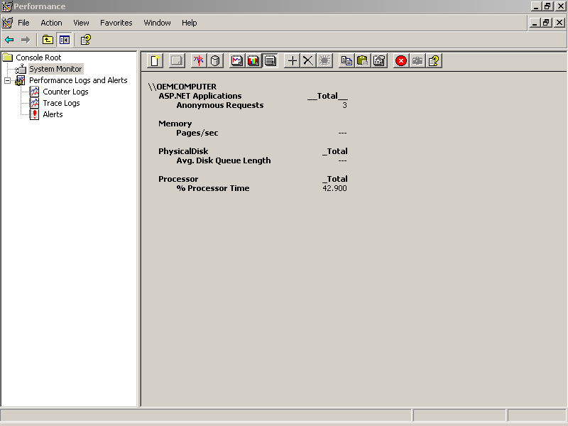
Figure 9-38. Viewing a log file in report form
More Info
The MMC Event Viewer and Performance snap-ins provide a way to monitor the health of a server, detect application errors, identify resource conflicts, and predict future hardware needs. For more information about performing these tasks, see the online Help provided with each of these snap-ins.
Repairing Deployed Applications
After a Web application is deployed, you can revise and repair it in place, without restarting the server or IIS.
To repair a deployed Web application, copy the new assembly (.dll) and/or content files (.aspx, .ascx, and so on) to the application folder on the server. ASP.NET automatically restarts the application when you replace the assembly; you do not need to install or register the assembly on the server.
ASP.NET Web applications also have a limited ability to repair themselves through process recycling. Process recycling is the technique of shutting down and restarting an ASP.NET worker process (aspnet_wp.exe) that has become inactive or is consuming excessive resources. You can control how ASP.NET processes are recycled through attributes in the processModel element in the Machine.config file, as shown in boldface here:
<processModel
enable="true"
timeout="Infinite"
idleTimeout="Infinite"
shutdownTimeout="0:00:05"
requestLimit="Infinite"
requestQueueLimit="5000"
restartQueueLimit="10"
memoryLimit="60"
webGarden="false"
cpuMask="0xffffffff"
userName="machine"
password="AutoGenerate"
logLevel="Errors"
clientConnectedCheck="0:00:05"
comAuthenticationLevel="Connect"
comImpersonationLevel="Impersonate"
responseRestartDeadlockInterval="00:09:00"
responseDeadlockInterval="00:03:00"
maxWorkerThreads="25"
maxIoThreads="25"/>
Table 9-4 describes the processModel attributes that relate to process recycling.
Table 9-4. Process Recycling Attributes
Attribute | Specifies
timeout | The amount of time (hh:mm:ss) before the process is shut down and restarted. Use this setting to automatically recycle a process after a certain number of requests as a preventive measure.
shutDownTimeOut | How much time each process has to shut itself down. After this amount of time, the process is terminated by the system if it still running.
requestLimit | The number of queued requests to serve before the process is shut down and restarted. Use this setting the same way you use the timeout attribute.
restartQueueLimit | The number of queued requests to retain while the process is shut down and restarted.
memoryLimit | The percentage of physical memory the ASP.NET process is allowed to consume before that process is shut down and a new process is started. This setting helps prevent memory leaks from degrading the server.
responseRestartDeadlockInterval | The amount of time to wait before restarting a process that was shut down because it was deadlocked. This setting is usually several minutes to prevent applications with serious errors from degrading the server.
responseDeadlockInterval | The amount of time to wait before restarting a process that is deadlocked. The process is restarted if there are queued requests and the process has not responded within this time limit.
Tuning Deployed Applications
ASP.NET Web applications have a number of settings you can control to tune performance after the applications are deployed:
- Use the processModel element’s attributes in the server’s Machine.config file to control the number of threads and the time-out behavior that the server provides for Web applications.
- Use the sessionState element’s attributes in the application’s Web.config file to control how Session state information is saved.
The following sections discuss each of these techniques.
Adjusting processModel Attributes
The processModel element in the server’s Machine.config file provides attributes that control certain performance aspects, such as the maximum number of requests to be queued, how long to wait before checking whether a client is connected, and how many threads to allow per processor, as shown here in boldface:
<processModel
enable="true"
timeout="Infinite"
idleTimeout="Infinite"
shutdownTimeout="0:00:05"
requestLimit="Infinite"
requestQueueLimit="5000"
restartQueueLimit="10"
memoryLimit="60"
webGarden="false"
cpuMask="0xffffffff"
userName="machine"
password="AutoGenerate"
logLevel="Errors"
clientConnectedCheck="0:00:05"
comAuthenticationLevel="Connect"
comImpersonationLevel="Impersonate"
responseRestartDeadlockInterval="00:09:00"
responseDeadlockInterval="00:03:00"
maxWorkerThreads="25"
maxIoThreads="25"/>
Table 9-5 describes the processModel attributes that relate to performance tuning.
Table 9-5. Performance Attributes
Attribute | Specifies
requestQueueLimit | The number of queued requests allowed before ASP.NET returns response code 503 (Server too busy) to new requests
clientConnectedCheck | The amount of time (hh:mm:ss) to wait before checking whether a client is still connected
maxWorkerThreads | The maximum number of threads per processor
maxIOThreads | The maximum number of I/O threads per processor
In general, lowering these settings allows your server to handle fewer clients more quickly. Increasing these settings permits more clients and more queued requests, but slows response times.
Adjusting sessionState Attributes
Storing state information for each client session takes time. If your Web application does not use Session state variables, you should turn off Session state tracking.
To turn off Session state, in the application’s Web.config file, set the sessionState element’s mode attribute to “Off”, as shown here:
<sessionState
mode="Off"
stateConnectionString="tcpip=127.0.0.1:42424"
sqlConnectionString="data source=127.0.0.1;user id=sa;password="
cookieless="false"
timeout="20"
/>
Turning off Session state means that you can’t use Session state variables in code anywhere in the application.
Optimization Tips
Think of tuning as making adjustments to a deployed application that don’t affect code. Optimization usually refers to writing code in a way that executes more quickly or consumes fewer resources. In general, optimizations simply reflect the good programming practices that you have learned so far in this book. Some of the most important points are summarized here:
- Turn off debugging for deployed applications.
Code that has been compiled with release options runs faster than code compiled with debug options.
- Avoid round-trips between the client and server.
ASP.NET uses postbacks to process server events on a page. Try to design Web forms so that the data on the Web form is complete before the user posts the data to the server. You can use the validation controls to ensure that data is complete on the client side before the page is submitted.
- Turn off Session state if it isn’t needed.
In some cases, you can design your code to use other techniques, such as cookies, to store client data.
- Turn off ViewState for server controls that do not need to retain their values.
Saving ViewState information adds to the amount of data that must be transmitted back to the server with each request.
- Use stored procedures with databases.
Stored procedures execute more quickly than ad hoc queries.
- Use SqlDataReader rather than data sets for read-forward data retrieval.
Using SqlDataReader is faster and consumes less memory than creating a data set.
When applying these optimization tips, please be guided by good sense. For instance, if you need to retain data about a client session, go ahead and use Session state rather than write your own implementation to do the same thing.
Lesson 5: Deploying Across Multiple Servers
Web applications that serve a large number of users or that present large amounts of data need to able to add capacity as users’ demands increase. The ability to add capacity to an application is called scalability. ASP.NET Web applications support this concept through their ability to run in multiple processes and to have those processes distributed across multiple CPUs and/or multiple servers.
A Web application running on a single server that has multiple CPUs is called a Web garden in the ASP.NET documentation. A Web application running on multiple servers is called a Web farm. In this lesson, you’ll learn how to enable your Web application to use each of these server configurations.
After this lesson, you will be able to
- Configure a server with multiple processors to run a Web application on several or all of its CPUs
- Run a Web application on multiple servers
- Use a state server to share Session state information between multiple instances of the same Web application
- Share Session state information using a SQL database
Estimated lesson time: 10 minutes
Scaling Up with Multiple Processors
If your server has multiple processors, you can specify that ASP.NET runs on all or some of the CPUs by setting the webGarden attribute of the processModel element in the server’s Machine.config file, as shown here in boldface:
<processModel
enable="true"
timeout="Infinite"
idleTimeout="Infinite"
shutdownTimeout="0:00:05"
requestLimit="Infinite"
requestQueueLimit="5000"
restartQueueLimit="10"
memoryLimit="60"
webGarden="true"
cpuMask="0xffffffff"
userName="machine"
password="AutoGenerate"
logLevel="Errors"
clientConnectedCheck="0:00:05"
comAuthenticationLevel="Connect"
comImpersonationLevel="Impersonate"
responseRestartDeadlockInterval="00:09:00"
responseDeadlockInterval="00:03:00"
maxWorkerThreads="25"
maxIoThreads="25"
/>
Table 9-6 describes the processModel attributes that relate to Web gardens.
Table 9-6. Web Garden Attributes
Attribute | Usage
webGarden | Set to “true” to run ASP.NET Web applications on more than one processor on this server.
cpuMask | Specifies which CPUs should run ASP.NET Web applications. The setting “0xffffffff” runs the applications on all CPUs.
The cpuMask attribute is a bit mask used to turn ASP.NET on (1) or off (0) for each CPU on the server. For example, binary 1101 turns ASP.NET on for CPUs 0, 2, and 3 on a four-CPU server, leaving CPU 1 free for other uses. Binary 1101 maps to the hexadecimal setting “0x0000000d”.
Running ASP.NET on multiple processors requires that you take special steps to handle Application and Session state information. See the section “Sharing State Information,” later in this lesson, for more information.
Scaling Up with Multiple Servers
For multiple servers to handle requests for a single HTTP address, you need to install load balancing to your network. Load-balancing services can be provided by hardware or software solutions.
Microsoft Windows 2000 Advanced Server and Microsoft Windows 2000 Datacenter both include Network Load Balancing (NLB) software to distribute requests to multiple servers. See the Visual Studio .NET online Help topic “Network Load Balancing Provider” for more information about installing and using this tool.
When load balancing is enabled for your network, you can install your Web application on multiple servers and have client requests distributed automatically to the least busy server at any given time.
Running a Web application on multiple servers requires that you take special steps to handle Application and Session state information. See the following section for more information.
Sharing State Information
In both a Web garden and a Web farm, client requests are directed to the ASP.NET process that is currently least busy. That means that a single client can interact with different CPUs or servers over the course of his or her session. This has the following implications for Application and Session state variables:
- Application state variables are unique to each separate instance of the Web application.
Clients can share information through Application state if the Web application is running on a Web garden or a Web farm.
- Session state variables are stored in-process by default.
To enable Session state in a Web garden or Web farm, you need to specify a Session state provider.
The following sections explore these issues in more detail.
Sharing Application State
To share data across multiple sessions in a Web garden or Web farm, you must save and restore the information using a resource that is available to all the processes. This can be done through an XML file, a database, or some other resource using the standard file or database access methods.
Sharing Session State
ASP.NET provides two built-in ways to share Session state information across a Web garden or Web farm. You can share Session state using:
- A state server, as specified by a network location
This technique is simple to implement and doesn’t require you to install Microsoft SQL Server.
- A SQL database, as specified by a SQL connection
This technique provides the best performance for storing and retrieving state information.
To share Session state information using a state server, follow these steps:
- In the Web application’s Web.config file, set the sessionState element’s mode and stateConnectionString attributes. For example, the following settings use the state server located at the TCP/IP address 192.168.1.102 on port 42:
- <sessionState
- mode="StateServer"
- stateConnectionString="tcpip=192.168.1.102:42"
- sqlConnectionString="data source=192.168.1.102;user id=sa;password="
- cookieless="false"
- timeout="20"
/>
- Run the aspnet_state.exe utility on the Session state server. The aspnet_state.exe utility is installed in the \WINDOWS\Microsoft.NET \Framework\version folder when you install Visual Studio .NET Professional or Visual Studio .NET Enterprise Architect editions.
To share Session state information using a SQL database, follow these steps:
- In the Web application’s Web.config file, set the sessionState element’s mode and sqlConnectionString attributes. For example, the following settings use the SQL Server located at the TCP/IP address 192.168.1.102:
- <sessionState
- mode="SQLServer"
- stateConnectionString="tcpip=192.168.1.102:42"
- sqlConnectionString="data source=192.168.1.102;user id=sa;password="
- cookieless="false"
- timeout="20"
/>
- Run the InstallSqlState.sql utility on the Session state server. This utility installs the SQL database that shares Session state information across processes. The InstallSqlState.sql utility is installed in the \WINDOWS\Microsoft.NET \Framework\version folder when you install Visual Studio .NET Professional, Visual Studio .NET Enterprise Developer, or Visual Studio .NET Enterprise Architect editions.
Summary
- Set the build option to Release and the debug attribute to “false” in Web.config before building your application for deployment.
- Use the AssemblyInfo.vb or AssemblyInfo.cs file to identify the application’s assembly and provide versioning information.
- To deploy a Web application, use the Visual Studio .NET upload tools or simply copy the application’s assembly and content files to the server.
- Set the security privileges on the ASPNET user account to enable your Web application to write files or access other security-restricted resources on the server.
- After deployment, monitor the Web application using the MMC Event Viewer and Performance Logs and Alerts snap-ins.
- You can repair Web applications by uploading new versions of the application’s assembly or content files to the server.
- Web applications with memory leaks or other problems can repair themselves through ASP.NET process recycling.
- To enable a Web garden, use the processModel element attributes in the server’s Machine.config file.
- To enable a Web farm, use a load balancer to distribute requests to multiple servers.
- For both Web gardens and Web farms, share Session state information by setting the sessionState element in the application’s Web.config file.
Lab: Building and Deploying a Web Application
In this lab, you’ll prepare a Web application for deployment, deploy the application to a server, and monitor and tune the application’s performance. Before you begin, choose one of the applications you completed in an earlier chapter—or choose a Web application that you have completed on your own—to use for the exercises that follow.
This lab covers material that applies to all types of Web applications, so it will be more interesting if you choose an application you want to share with others or are interested in using yourself over the Internet.
Estimated lesson time: 30 minutes
Exercise 1: Prepare the Application

In this exercise, you’ll build a release version of the Web application. Use the skills you learned in Lesson 1 to complete the following major tasks:
- Identify the application and set its version number in the AssemblyInfo.vb or AssemblyInfo.cs file.
- Set the compilation element’s debug attribute to “false” in the application’s Web.config file.
- Set the application’s build option to Release.
- Build the application.
Exercise 2: Deploy the Application
How you deploy your application depends on the type of server you have available. If you are hosting your applications through a Web hosting service, as discussed in Chapter 1, “Introduction to Web Programming,” use the Visual Studio .NET upload tools to deploy your application to the hosting service.
If you are hosting applications on your own server, use the skills you learned in Lesson 2 in this chapter to perform the following tasks:
- Create a virtual folder for the application using IIS on the server.
- Copy the Web application to the virtual folder.
- View the security settings on the server to verify that the ASPNET user account has the permissions to perform the tasks required by your application.
- If needed, grant access to resources used by your application.
- Run the application from the server to verify that your security settings allow the application to run correctly.
Exercise 3: Chart Application Performance
In this exercise, you’ll use the MMC Performance snap-in to keep a log of the number of requests processed by ASP.NET and chart those requests against processor activity on the server. When complete, the chart will appear similar to that shown in Figure 9-39.
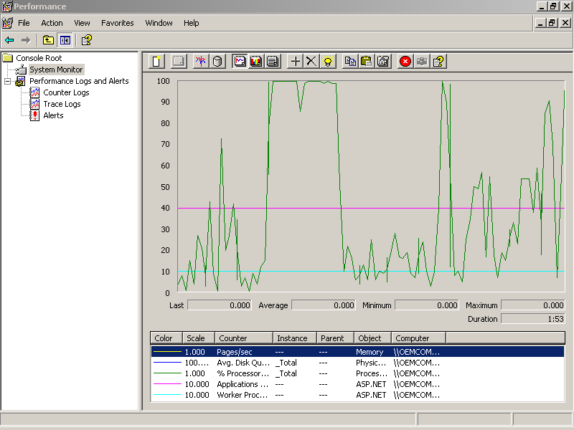
Figure 9-39. Charting Web application performance
Use the skills you learned in Lesson 3 to perform the following tasks:
- Run the MMC Performance snap-in and connect to the server that’s running the deployed Web application. If you deployed your application to a Web hosting service in Exercise 2, you won’t be able to connect to that server. Instead, run the Web application locally on your development machine and connect to your local machine instead.
- Create a new counter log named Exercise 3.
- Add the counters to the log, as shown in the following table:
Performance object | Counter
Processor | %Processor time
ASP.NET applications | Anonymous requests
ASP.NET | Applications running
ASP.NET | Worker processes running
- Start the counter log and then stop it after a few minutes to collect data about the server.
- Select the System Monitor in the snap-in, and change the monitor’s properties to view the log files:
  - Right-click the System Monitor, and select Properties from the shortcut menu.
  - Click the Properties Source tab, select Log Files, and then click Add to add the log files to the monitor.
  - Click the Properties Data tab, and then click Add to add the ASP.NET counters to the monitor.
  - On the Properties Data tab, set the scale of each of the ASP.NET counters to 10.
  - Click OK to view the log as a chart.
  - In the System Monitor, select Report to view the log data in text form.
  - Experiment with other counters, such as ASP.NET application errors, cache hits, and so on.
Review
The following questions are intended to reinforce key information presented in this chapter. If you are unable to answer a question, review the appropriate lesson and then try the question again. Answers to the questions can be found in the appendix.
- What permissions do Web applications run under by default?
- Why is the Machine.config file important to deployed Web applications?
- How do you configure a setup project to install an application over the Web?
- How do you distribute shared components as part of an installation program?
- How does deploying to a Web farm or a Web garden affect Session state in a Web application?

